Infectious Diseases Policy

RATIONAL
The way that children interact with each other and with adults in education and care services means that diseases can quickly spread in a variety of ways. Whilst it is not possible to prevent the spread of all infections and diseases, minimising the risk is enhanced through:
- effective hand hygiene
- exclusion of ill children, educators and other staff
- immunisation

Our Service has a duty of care to ensure that children families, educators, and visitors of the Service are provided with a high level of protection during the hours of the Service’s operation.

In order to prevent the spread of infectious diseases through interpersonal contact, our service will adhere to the exclusion period table, published by the National Health and Medical Research Council.

Infectious disease, in relation to a participating jurisdiction, means an infectious disease that is designated under a law of that jurisdiction or by a health authority (however described) as a disease that would require a person with the disease to be excluded from an education and care Service”.

How infections occur
An infection occurs when harmful germs (microorganisms) enter the body, multiply and cause disease. The chain of infection refers to how germs spread. When an infection occurs, three things are involved:
- the source – the germs and where they live
- spread – how the germs get out of one person and move to a new person
- the new host – a susceptible person (someone who can be infected) with a way for the germs to get in.
All the steps in the chain need to occur for germs to spread from a source to a susceptible person. By breaking the chain at any stage, you can prevent the spread of infection.

AIM

KAZ Early Learning Centre will minimise the spread of potentially infectious diseases between children, and the Service, by excluding children, educators/staff, and visitors, who may have an infectious disease or are too ill to attend the Service.

IMPLEMENTATION

To minimise the spread of Infectious disease between children, educators/staff and visitors, KAZ Early Learning Centre will:
- Exclude from care and notify the local Public Health Unit and provide details of any known or suspected persons with any of the following diseases:
- Diphtheria
- Haemophilus Influenzae type b (Hib)
- Measles
- Meningococcal disease
- Mumps
- Pertussis (whooping cough)
- Poliomyelitis
- Rubella (German measles)
- Tetanus

KAZ Early Learning Centre will also seek advice from their local Public Health Unit when they suspect an infectious disease outbreak is affecting the service such as outbreaks of gastrointestinal (refer to this Gastro Pack for Childcare Centres ) or respiratory illness.

- Exclude a child or educator/staff member with any of the following symptoms which might indicate they have a potentially serious illness:
  - vomiting,
  - rash, especially if purplish or hemorrhaging spots (possibly meningococcal) or blistering (possibly staphylococcal),
  - headache,
  - stiffness of the neck,
  - aversion to light (photophobia),
  - drowsiness or any unusual state of consciousness or behaviour,
  - convulsion or epileptic seizure.
  - severe pain anywhere (including toothache),
  - swelling of the lips, mouth, tongue, throat, neck or airways,
  - hives,
  - asthma, wheezing, or any difficulty breathing,
- Exclude a child or educator /staff member with any of the following symptoms which might indicate they have an infectious illness:
  - diarrhea,
  - generalised rash,
  - enlarged or tender lymph glands,
  - severe cough with fever,
  - head lice, nits, scabies, ringworm, impetigo, or mouth ulcers not yet treated,
  - mouth ulcers due to herpes simplex virus or coxsackie virus,
  - infection or yellow or green discharge of the eyes or ears,
  - if any other infectious disease is suspected.
- Exclude children, educators/staff, volunteers or visitors who have infectious diseases other than listed above in accordance with the NHMRC Recommended Minimum periods of exclusion.
- Ensure all educators/staff and persons working at the Service conform to all infectious disease policies.
- Make sure the child is comfortable, and is supervised by an educator/staff member, contact with other children will be avoided.
- Contact the child’s parents/guardians or, if they are unable to be contacted, an authorised nominee for emergencies as listed on the enrolment form. Inform the parents/guardian or authorised nominee of the child’s condition, or suspected condition, and ask that the child be picked up from the Service as soon as possible.
- Ensure all bedding, towels, clothing, etc., which has been used by the child is disinfected – these articles should be washed separately and, if possible, aired in the sun to dry.
- Ensure all contact toys are separated and disinfected.
- Ensure all eating utensils are separated and sterilised.
- Information will be available in relevant community languages when required.
- Inform all families of the presence of an infectious disease in the Service.
- The Service will ensure confidentially of any personal or health related information obtained by the Service, in relation to any children, educators/staff, children’s parents/guardian and families.
- If a child or an educator/staff member has been unable to attend the Service because of an infectious illness, when the child or an educator/staff member has fully recovered the family, or an educator/staff member is encouraged to obtain a certificate from their doctor which specifically states the child or an educator/staff member is not infectious and is able to attend care, or return to work.

Responsibilities of the Approved Provider

- Ensure the service operates in line with the Children (Education and Care Services) National Law (NSW) 2010 and Education and Care Services National Regulations.
- Ensure children are protected from harm by ensuring relevant policies and procedures are followed regarding health and safety within the Service.
- Collect, maintain, and appropriately store the required enrolment documents and enrolment information, including health and immunisation records of children in the Service.
- Ensuring that where there is an occurrence of an infectious disease at the service, reasonable steps are taken to prevent the spread of that infectious disease (National Regulation 88(1)).
- Ensuring that where there is an occurrence of an infectious disease at the service, a parent/guardian or authorised emergency contact of each child at the service is notified of the occurrence as soon as is practicable.
- As soon as practicable, a family member or authorised emergency contact of each child being cared for must be notified of the occurrence (National Regulation 88(2)).
- Ensuring that information from the Department of Health about the recommended minimum exclusion periods is displayed at the service, and is adhered to in the event of an outbreak of an infectious disease.
- Notifying the Regulatory Authority and parent/guardian within 24 hours of a serious incident including when a child becomes ill at the service or medical attention is sought while the child is attending the service (National Regulation 86).
- In any other case, within 7 days of the relevant event or within 7 days of the approved provider becoming aware of the relevant information (National Regulation 176(2)(c)).
- Ensuring that appropriate and current information and resources are provided to staff and parents/guardians regarding the identification and management of infectious diseases, blood-borne viruses and infestations.
- Ensure the medical conditions policy is given to families.
- Keeping informed about current legislation, information, research and best practice.
- Ensuring that any changes to the exclusion table or immunisation schedule are communicated to families and staff immediately.

Responsibilities of the Nominated Supervisor

- Contacting the parents/guardians of a child suspected of suffering from an infectious or vaccine- preventable disease, or of a child not immunised against a vaccine-preventable disease that has been detected at the service, and requesting the child be collected as soon as possible.
- Notifying a parent/guardian or authorised emergency contact person when a symptom of an excludable infectious illness or disease has been observed.
- Ensuring that a minimum of one staff with current approved first aid qualifications is in attendance and immediately available at all times the service is in operation (National Regulation 136).
- Establishing good hygiene and infection control procedures and ensuring that they are adhered to by everyone at the service.
- Ensuring the exclusion requirements for infectious diseases are adhered to as per the recommended minimum exclusion periods, notifying the Approved Provider and parents/guardians of any outbreak of infectious disease at the service, and displaying this information in a prominent position.
- Requesting that parents/guardians notify the service if their child has, or is suspected of having, an infectious disease or infestation.
- Providing information and resources to families to assist in the identification and management of infectious diseases and infestations.
- Maintaining confidentiality at all times.
- Provide relevant sourced materials to families.
- Ensuring that an “Incident, Injury, Trauma and Illness” record is completed as soon as practicable or no later than 24 hours of the illness occurring (National Regulation 86).
- A hygienic environment is maintained.
- Children do not attend the Service if they are unwell. If a child has been sick they must be well for 24hrs before returning to the Service.
- Toys and equipment will be washed with detergent and air-dryed.
- Floor surfaces will be cleaned on a daily basis after each meal and at the end of each day.
- Toilets/bathrooms will be cleaned in the middle of the day, the end of the day and whenever needed throughout the day.
- Pregnant staff do not change nappies or assist in toileting or cleaning up toileting accidents to prevent unexpected cross contamination and risk to pregnancy.

Responsibilities of the Educators

- Ensure that any children that are suspected of having an infectious illness are responded to and their health and emotional needs supported at all times.
- Implement appropriate health and safety procedures, when tending to ill children.
- Ensure that families are aware of the need to collect their children as soon as practicable to ensure the child’s comfort.
- Provide varied opportunities for children to engage in hygiene practices, including routine opportunities, and intentional practice.
- Observing signs and symptoms of children who may appear unwell and informing the Nominated Supervisor.
- Providing access to information and resources for parents/guardians to assist in the identification and management of infectious diseases and infestations.
- Monitoring any symptoms in children that may indicate the presence of an infectious disease.
- Maintaining confidentiality at all times.

Responsibilities of the Families

- Providing Immunisation documentation upon enrolment and as the child receives subsequent immunisations.
- Keep their children at home if they are unwell or have an excludable infectious disease.
- Where a child has an acceptable exemption, keep the children at home when an infectious disease has been confirmed at the service and the child is not fully immunised against that infectious disease, until there are no more occurrences of that disease and the exclusion period has ceased.
- To arrange prompt collection of their unwell child if contacted by the Service.
- Inform the service if their child has an infectious disease or has been in contact with a person who has an infectious disease.

Immunisation Requirements

From the 1st of January 2018 all children attending a centre-based service must be up to date with their vaccinations and provide an up to date AIR Immunisation History Statement provided through Medicare on the MyGov account to the service upon enrolment or when immunisations have been updated. Should a child not be up to date then the family will not receive any benefit from the government. Enrolling children who are not immunised could result in a financial penalty to the Approved Provider.

Children who cannot be fully vaccinated due to a medical condition or who are on a recognised catch-up schedule will still be able to be enrolled upon presentation of the appropriate form signed by a medical practitioner.
To find out more information visit NSW Health website in the link below where they offer a toolkit with relevant information regarding the requirements for immunisation.

There are no current requirements for educators to receive vaccinations, but it is highly recommended due to the risks.

If a child has not been immunised, they may be excluded from care during outbreaks of some infectious diseases, even if their child is well, depending on advice from the Public Health Unit.

The Approved Provider/Nominated Supervisor will ensure that this policy is maintained and implemented at all times.

Procedure and forms

- Incident, Injury, Illness and Trauma Record
- Recommended Minimum Exclusion Periods Poster – NHMRC

Links to other policies

- Enrolment and Orientation Policy
- Immunisation and Exclusion Policy
- Incident, Injury, Trauma and Illness Policy

Links Education and Care Services National Regulations 2011, National Quality Standard 2011

Regulation | 77 | Health, hygiene and safe food practices
Regulation | 85 | Incident, injury, trauma and illness policies and procedures
Regulation | 86 | Notification to parents of incident, injury, trauma and illness
Regulation | 87 | Incident, injury, trauma and illness record
Regulation | 88 | Infectious diseases
Regulation | 90 | Medical conditions policy
Regulation | 162 | Health information to be kept in enrolment record

NQS | QA2.1.1 | Each child’s wellbeing and comfort is provided for, including appropriate opportunities to meet each child’s need for sleep, rest and relaxation
NQS | QA2.1.2 | Effective illness and injury management and hygiene practices are promoted and implemented

Sources

- Education and Care Services National Regulations 2011
- Guide to the National Quality Framework Section 4 – Operational Requirements https://www.acecqa.gov.au/nqf/about/guide
- National Health and Medical Research Council. (2012). Staying Healthy: Preventing infectious diseases in early childhood education and care services. 6th edition. https://www.nhmrc.gov.au/sites/default/files/documents/attachments/ch55-staying-healthy.pdf
- National Health and Medical Research CounciL. Recommended minimum exclusion periods.
- https://www.nhmrc.gov.au/about-us/publications/staying-healthy-guidelines/posters-information-sheet
- NSW Health - https://www.health.nsw.gov.au/immunisation/Publications/parent-childcare-brochure.pdf
- https://www.health.nsw.gov.au/Infectious/gastroenteritis/Documents/ccc-gastro-pack.pdf

Further reading and useful websites (Consistent with the approach of the National Quality Framework, the following references have prioritised efficacy and appropriateness to inform best practice, and legislative compliance over state or territory preferences.)

- Department of Health (Australian Government). National Immunisation Program. https://www.health.gov.au/initiatives-and-programs/national-immunisation-program
- National Health and Medical Research Council – http://www.nhmrc.gov.au/
- Department of Health
- http://www.health.nsw.gov.au/Infectious/Pages/default.aspx http://www.health.nsw.gov.au/Infectious/controlguideline/Pages/default.aspx
- Department of Health Immunisation Toolkit
- http://www.health.nsw.gov.au/immunisation/Publications/immunisation-enrolment-toolkit.pdf

Related Telephone Numbers
- Early Childhood Directorate - 1800 619 113
- Public Health Unit- 1300 066 055
- Emergency Services – 000

Policy review

The Service encourages staff and parents to be actively involved in the annual review of each of its policies and procedures. In addition, the Service will accommodate any new legislative changes as they occur and any issues identified as part the Service’s commitment to quality improvement. The Service consults with relevant recognised authorities as part of the annual review to ensure the policy contents are consistent with current research and contemporary views on best practice.

Version Control

Version | Date Reviewed | Comments/Amendments
1 | January 2018 | Updated to changed NQF requirements 1 February 2018.
2 | September 2019 | Updated references.
3 | November 2020 | Updated references.
4 | December 2021 | Updated references.
5 | October 2022 | Updated References  Added some points regarding immunisation requirements  Exclusion table and web links updated.
6 | January 2023 | Point added to responsibilities of parents.
7 | January 2024 | Added definitions
8 | February 2025 | Updated sources and weblinks

Next Review Date: February 2026
Family, Educator and Staff Comments:

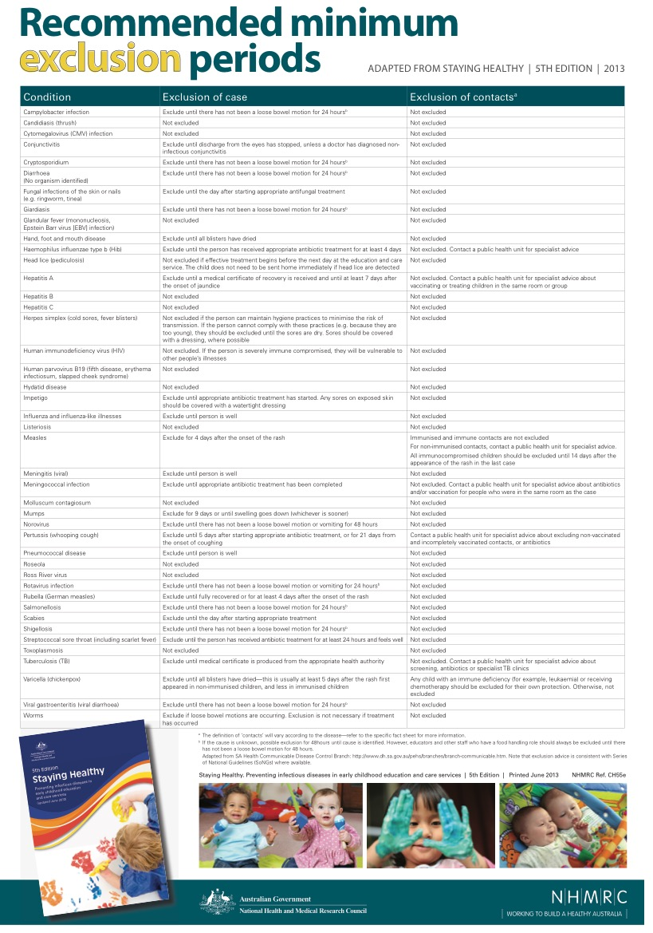

Note: The NHMRC recommends that children who are physically unwell should be excluded from attending school, pre-school and child care centres. This list should be read in conjunction with the National Health and Medical Research Council’s publication: Staying Healthy in Child Care. 5th edition, Canberra.

